Info 1112 Section 12

Lab # 2

Douglas Oak

100356690

Dr. Warren Edwards Ph.D.

Review Exercises:

R2.1

|  |  |
| --- | --- |
| Expression | Value |
| 28/4 –2 | C:\Users\Concierge\Desktop\Capture.JPG 5 |
| 6 + 12 * 2 – 8 | C:\Users\Concierge\Desktop\Capture.JPG 8 |
| 4 + 8 * 2 | C:\Users\Concierge\Desktop\Capture.JPG 20 |
| 6 + 17 % 3 - 2 | C:\Users\Concierge\Desktop\Capture.JPG 6 |
| 2 + 22 * (9 - 7) | C:\Users\Concierge\Desktop\Capture.JPG 46 |
| (8 + 7) * 2 | C:\Users\Concierge\Desktop\Capture.JPG 30 |
| (16 + 7) % 2 - 1 | C:\Users\Concierge\Desktop\Capture.JPG 0 |
| 12 / (10 – 6) | C:\Users\Concierge\Desktop\Capture.JPG 3 |
| (19 – 3 ) * (2 + 2) / 4 | C:\Users\Concierge\Desktop\Capture.JPG 16 |

R2.2

1. a = 12 * x;
2. z = 5 * x + 14 * y + 6 * k;
3. y = std::pow(x , 4);
4. g = (h + 12) / (4 * k);
5. std::pow(a, 3) / std::pow(b , 2) * std::pow(k , 4);

R2.3

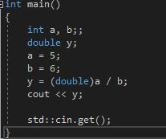

C:\Users\Concierge\Desktop\Capture.JPG

unitsEach = (double)qty / salesReps;

R2.4

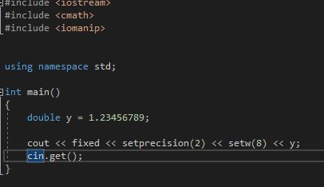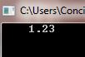

std::cout << fixed << setprecision(2) << setw(8) << divSales;

R2.5

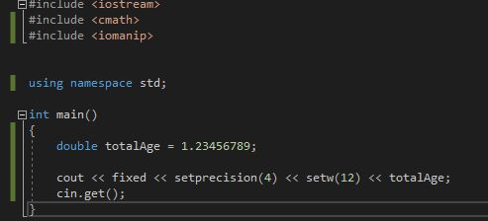

C:\Users\Concierge\Desktop\Capture.JPG

Std::cout << fixed << setprecision(4) << setw(12) << totalAge;

R2.6

Predicted output = Your monthly wages are 3291

Actual is:

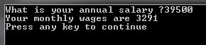

Coding assignment:

/*

This program takes in 5 test scores and returns the average of those 5 test scores

*/

#include <iostream>

#include <iomanip>

#include <string>

using namespace std;

double score_taker(string msg) //a function that takes in a user score request and returns a score

{

double score;

cout << msg; //requests a score

cin >> score;

return score; //returns a score

}

int main()

{

double test_array[5]; //initializing test score array

double total = 0, average;

double num_test_scores = 5;

for (int i = 0; i < 5; i++) //for loop to iterate through the array

{

if (i == 0) //1st test score input

{

test_array[0] = score_taker("Please input the first test score:\n");

}

else if (i == 1) // 2nd test score input

{

test_array[1] = score_taker("Please input the second test score:\n");

}

else if (i == 2) // 3rd test score input

{

test_array[2] = score_taker("Please input the third test score:\n");

}

else if (i == 3) // 4th test score input

{

test_array[3] = score_taker("Please input the forth test score:\n");

}

else

{

test_array[4] = score_taker("Please input the fifth test score:\n");

}

}

for (int i = 0; i < 5; i++) //second for loop to calculate teat score total

{

total += test_array[i];

}

average = total / num_test_scores; //calculates average

cout << "The average test score = " << setprecision(1) << fixed<< average; //outputs average with a precision of one decimal place

cout << endl;

cout << "Press any key to close"; //prevents program from closing too quickly

cin.get();

}

